Practice Quest:

1. Given the functions *j*(*x*)*=* 3*x –* 2 and *b*(*x*)*=* |*x* + 2| Which value of *x* results in $j\left(x\right)=b(x)$?
   1. −2 3. 2
   2. $\frac{2}{3}$ 4. 4
2. The flight paths of two Thunderbird jets are plotted on a Cartesian coordinate plane, and the equations of the jets’ flight paths are represented by *y*= 2*x*+ 3 and *y*= 0.5*x*. The best approximation of the intersection of the flight paths is
3. (−1.72, 3.3) 3. (0, 1)
4. (−1.50, 2.82) 4. (−2, −1)
5. Which table of values represents a linear relationship?

1. 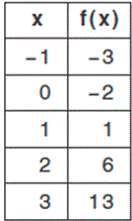 2. 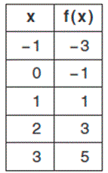 3. 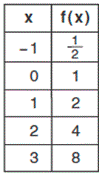 4. 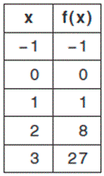4) Which of the three situations given below is best modeled by an exponential function?

I. A bacteria culture doubles in size every day.

II. A plant grows by 1 inch every 4 days.

III. The population of a town declines by 5% every 3 years.

1. I, only 3. II, only
2. I and II 4. I and III
   1. The exponential function *f*(*x*) = 15,000(1.02)*x*models the amount of money in a savings account over a period of time. What does the value 0.02 represent?
3. amount remaining in the account
4. original amount in the account
5. rate of growth
6. time
   1. A population that initially has 20 geese approximately doubles every 10 years.  Which graph represents this population?
7. 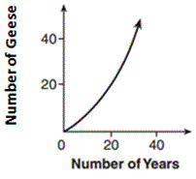2. 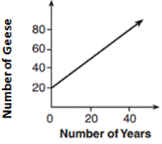3. 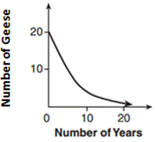4. 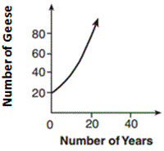
   1. Alex has a baseball card collection. He started with 5 cards. Every month, he doubles the number of cards in his collection which function represents *p*(*t*), the number of cards after *t* months?
8. *p*(*t*)*=* 2(5)*t*  3. *p*(*t*)*=*5(2)*t*
9. *p*(*t*)*=*2*t +* 5 4. *p*(*t*)*=* 5*t +* 2
   1. The value, *v*(*t*), of a car depreciates according to the function *v*(*t*) = *P*(0.85)*t*, where *P*is the purchase price of the car and *t*is the time, in years, since the car was purchased. State the percent that the value of the car *decreases*by each year. Justify your answer.
   2. which exponential equation models the data from the table below?

https://cl.castlelearning.com/Review/Courses/algebraii/q4834.gif?v=20100930061556

1. *y*= 4(2)*x  3. y*= 2(4)*x*
2. *y*= 8(2)*x 4. y*= –4(2)*x*
   1. A townhouse in San Francisco was purchased for $80,000 in 1975.  The appreciation of the building is modeled by the equation:  *A* = 80000(1.12)*t*, where *t* represents time in years.

What was the expected value of the townhouse in the year 2000? Round your answer to the *nearest dollar*.

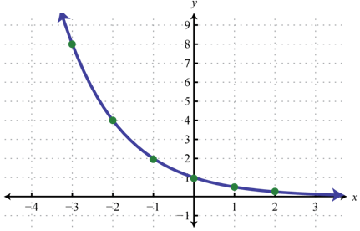11. a. Write a table of value for the graph

b. Write an appropriate function that represents the table of values using regression in the calculator.

c. Calculate the Correlation coefficient.

d. What is the range?

e. What is the average rate of change over ?

12. The population of Bridgeville, PA, is 5300 with a growth rate of 1.3% per year.

a. Explain what 5300 and 1.3% mean in this context of the problem:

b. Does the problem depict a growth or a decay factor? Why?

C. Write a function to model the number of people y after x number of years.

d. How many people live in Bridgeville after 5 years?

e. Graphically, how many years will it take for Bridgeville to have a population of 7320?

1. The Franklins inherited $3500, which they want to invest for their child’s future college expenses. They are trying to investigate 2 options. A simple interest account with a rate of 7%. Or a compound interest account with a rate of 8.25% interest compounded monthly, determine which options is a better option, if they are investing the money for 5 years.

Simple interest: $A=P(1+rt)$ Compound interest: https://cl.castlelearning.com/Review/Courses/algebra/q2926.gif?v=20040203123322

1. A company is considering building a manufacturing plant. They determine the weekly production cost at site *A* to be $A\left(x\right)= 3x^{2}$ while the production cost at site *B* is $B\left(x\right)= 3{(2)}^{x}$, where *x* represents the number of products, *in hundreds,* and *A*(*x*) and *B*(*x*) are the production costs, *in hundreds of dollars*
2. A. Graph the production cost functions on the set of axes below and label them site *A* and site *B*. (provide tables of values)

1. State the positive value(s) of x for which the production costs at the two sites are equal.
2. Which company a lower production cost for 100 products. Justify your answer.

**Zone 4: Solving exponential functions graphically**

1. Ryan had purchased a motorcycle for $ 4168. The value of the motorcycle has depreciated by 12% every year and it is now worth $ 2500. Graphically figure out how many years ago did Ryan purchase the motorcycle.



1. 2) The value of Jim’s investment is increasing by 4% each year. If his initial investment is $1200, determine the following. Write an equation which could be used to determine the total value of his investment after x years. Remember: In the exponential equation , a is the starting value and b is the growth/decay ratio.
2. Use your equation to determine the total value of his investment after 50 years algebraically.
3. Graphically determine when his investment will double up. Sketch

Review Practice:

* 1. Which expression is equivalent to 16*x*4 − 64?

1. (4*x*2 − 8)2 3. (8*x*2 − 32)2
2. (4*x*2 + 8)(4*x*2 − 8) 4. (8*x*2 + 32)(8*x*2 − 32)
   1. If 4*x*2- 100 = 0, the roots of the equation are
3. -25 and 25 3. -25, only
4. -5 and 5 4. -5, only
   1. What are the solutions to the equation *x*2− 8*x*= 10?
5. 4 ± square root of 10 3. 4 ± square root of 26
6. −4 ± square root of 10 4. −4 ± square root of 26
   1. When factored completely,  *x*3 − 13*x*2 −​ 30*x*is
7. *x*(*x*+ 3)(*x*− 10) 3. *x*(*x*− 3)(*x*− 10)
8. *x*(*x*+ 2)(*x*− 15) 4. *x*(*x*− 2)(*x*+ 15)

19) The domain of the function defined as *y* = 5*x* is

1. (−∞, 0] 3.  (−∞, 0)
2. (−∞, ∞) 4. [−∞, ∞]

20) Given the following expressions:

I. minus 5 eighths + 3 fifths  II. 1 half + square root of 2

III. square root of 5 times square root of 5  IV. 3 times square root of 49

Which expression(s) result in an irrational number?

1. II, only 3. III, only
2. I, III, IV 4. II, III, IV
   * 1. Joey enlarged a 3-inch by 5-inch photograph on a copy machine. He enlarged it four times. The table below shows the area of the photograph after each enlargement.

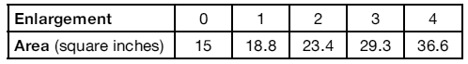

What is the average rate of change of the area from the original photograph to the second enlargement, to the *nearest tenth*?

1. 4.2 3.  4.5
2. 5.4 4.  6.0
   * 1. Solve for *x*:  2(*x* + 1) = 3(4 - *x*)
   1. -4 3. 2
   2. -2 4. 4
      1. 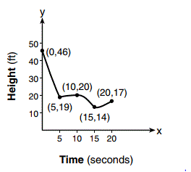 The graph below models the height of a remote-control helicopter over 20 seconds during flight. Over which interval does the helicopter have the *slowest* average rate of change?
3. 0 to 5 seconds
4. 5 to 10 seconds
5. 10 to 15 seconds
6. 15 to 20 seconds

24) Which graph does *not* represent a function?

1. 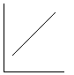 3. 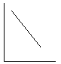
2. 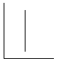 4. 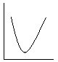

3] Graph the following functions:

 and find the value of x for which f(x)=h(x). Include tables of values to support your answer.

Do Now:

Solve by completing the square:

